NEWA meeting on “Nordic Experiment” and offshore observations and modeling

Date: February 2-3, 2016.

Meeting venue: UNEP DTU PARTNERSHIP, Marmorvej 51, 2100 Copenhagen Ø, Denmark 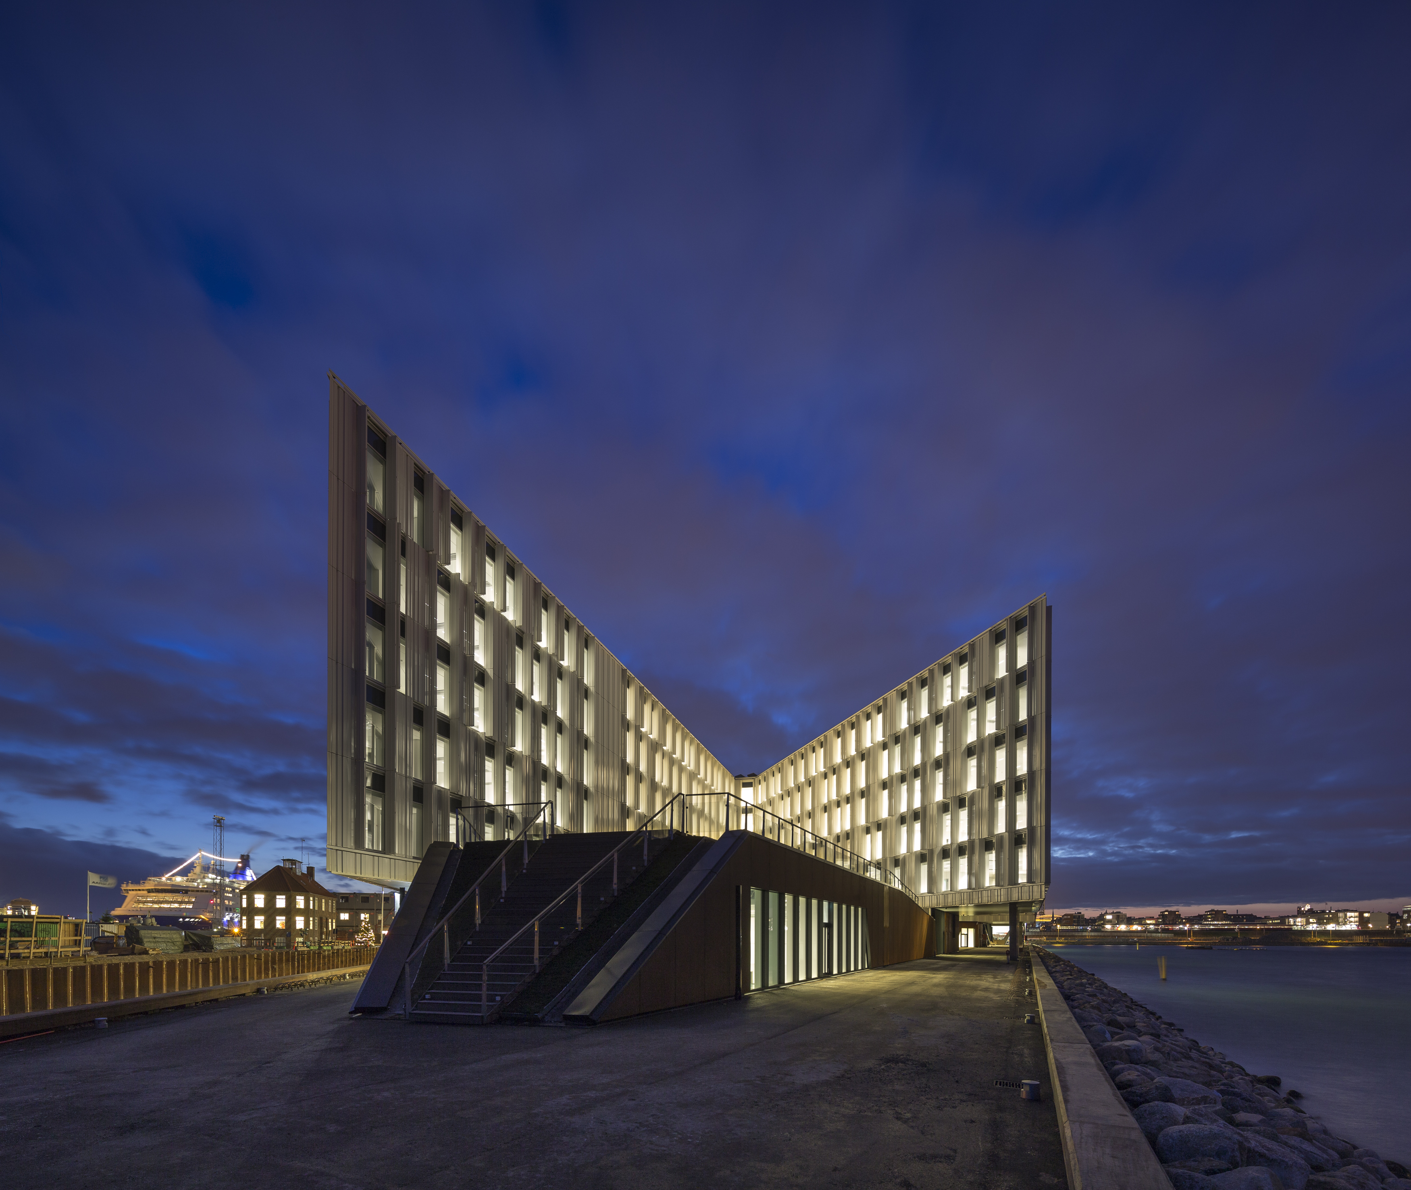

Meeting objective: To prepare joint work plans for the

* Using the RUNE coastal measurements for verification of meso-scale modeling
* Where to implement ferry-based lidars
* How to best use satellite imagery
* Final planning of forested site in Sweden (east of lake Vättern) and model validation
* How to make best use of the two-component horizontal scanning at Østerild

Expected participants:

Modelers and experimentalists involved in the Northern experiments and the offshore wind atlas

Tuesday February 2nd

### 9:00-9:30 Welcome. Motivation and expected outcome of the meeting

Jakob Mann, DTU

### 9:30-10:30

Julia Gottschall, Fraunhofer IWES. Ship-based wind profiling lidars – what are the possibilities?

Andrea Hahmann/Patrick Volker, DTU : Meso-scale intercomparisons – where do models differ?

### 10:30-11:00 Tea and coffee

### 11:00-12:00 Status from experiments and satellite

Charlotte Hasager, DTU: Status of the RUNE coastal experiment

Merete Badger, DTU: Envisat, Sentinel-1 and ASCAT and lifting method

### 12:00-13:00 Lunch

### 13:00-13:45 Joint work plans discussion resulting in action plan

Jakob Mann: Discussion: How could modellers use the RUNE data?

### 13:45-14:15 Guided tour of the UNEP building

### 14:15-15:00 Joint work plans discussion resulting in action plan (Con’t)

Julia Gottschall: Discussion: Where to deployed ferry-based lidars (please see map of ferry routes below)

### 15:00-15:30 Tea and coffee

### 15:30-16:15 Joint work plans discussion resulting in action plan (Con’t)

Charlotte/Merete: Discussion: What is the role of satellite imagery in NEWA?

### 16:15-16:35: Results of the questionnaire on wind atlas output parameters

Björn Witha (ForWind) presents.

### 16:35-16:55 Summary of the day, action plan list

Action items list: Jakob Mann

Dinner at 19:00 at restaurant SULT (to be confirmed)

Wednesday February 3rd

### 9:00-9:15 Welcome. Motivation and expected outcome of the day

Jakob Mann

### 9:15-10:30

Stefan Ivanell/Johan Arnquist, Uppsala: Status of experiment around 180 m mast in Sweden.

Ebba Dellwik, DTU: How can the Swedish experiment be used to verify models? Implications on the final experimental design.

### 10:30-11:00 Tea and coffee

### 11:00-12:30 Status on activities

Mike Courtney/ Jakob Mann: Dual-Doppler horizontal scanning at Østerild. Status and ideas on how the data are used for model validation.

Charlotte Hasager: Using wind climate (30-yr records) from satellite measurement (Special Sensor Microwave Imager) to observe long-term wind trends. Is it important for NEWA?

Ioanna Karagali, DTU: Discussion: Are there sources of offshore meteorological observations that are relevant for NEWA?

### 12:30-13:00 Summary of the day, action plan list

Charlotte Hasager/Jakob Mann Action items list.

### 13:00-14:00 Lunch and goodbye

