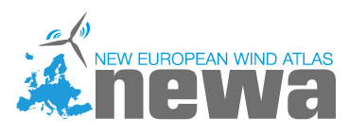

NEWA GENERAL PROJECT MEETING
23-25 October 2017

Participant Information
Title | Choose an item.
Participant Name:
Participant Surname:
Company:
Country:

Participation Dates

I will participate in the Monday Session, 23th October 2017

I will participate in the Tuesday Session, 24th October 2017

I will participate in the Wednesday Session, 25th October 2017

I will participate in all Sessions

I will join the Welcome Dinner, 23th October, 7.00 p.m.

Dietary requirements: Standard Vegetarian

Accommodation Information

Please book for me Single Room in Radisson Blu Hotel Latvija from 22.10.2017 to 26.10.2017

Please book for me Single Room in Radisson Blu Hotel Latvija for another dates,

from Click here to enter a date. to Click here to enter a date.

It should be noted that ONLY single room expenses in Radisson Blu Hotel Latvija will be paid by Latvian Consortium from common good resources.

Any other information:
Please submit registration form till 15th September 2017.

E-mail: sorlova@edi.lv
Phone: +371 26735027

